Syeda Reeha Quasar

14114802719

4C7

Aim

Installation of NS3 simulator and its steps.

Experiment - 3

Computer Networks Lab

# **EXPERIMENT – 3**

## **Aim:**

Installation of NS3 simulator and its steps.

## **Theory:**

Following are the basic steps which must be followed for installing NS3

1. Install prerequisite packages
2. Download ns3 codes
3. Build ns3
4. Validate ns3

### Prerequisite packages for Linux are as follows:

1. Minimal requirements for Python: gcc g++ python
2. Debugging and GNU Scientific Library (GSL) support: gdbpython-dev,valgrind gsl-bin,libgsl0-dev,libgsl0ldbl, Network Simulation Cradle (nsc): flex,bison
3. Reading pcap packet traces: tcpdump
4. Database support for statistics framework: sqlite,sqlite3
5. XML-based version of the config store: libxml2
6. A GTK-based configuration system: libgtk2.0-0
7. Experimental with virtual machines and ns-3: vtun,lxc

### Detail steps are as follows:

1. $sudo apt-get update / dnf update
2. $sudo apt-get upgrade / dnf upgrade
3. Once ubuntu/fedora is installed run following command opening the terminal(ctrl+alt+T) window.
4. To install prerequisites dependency packages- Type the following command in terminal window.
5. $sudo apt-get/ dnf install gcc g++ python python-dev mercurial bzr gdb valgrind gsl-bin libgsl0-dev libgsl0ldbl flex bison tcpdump sqlite sqlite3 libsqlite3-dev libxml2 libxml2- dev libgtk2.0-0 libgtk2.0-dev uncrustify doxygen graphviz imagemagick texlive texlive-latex-extra texlive-generic-extra texlive-generic-recommended texinfo dia texlive texlive- latex-extra texlive-extra-utils texlive-generic-recommended texi2html python-pygraphviz python-kiwi python-pygoocanvas libgoocanvas-dev python-pygccxml
6. After downloading NS3 on the drive, extract all the files in the NS3 folder, which you have created.
7. Then you can find build.py along with other files in NS3 folder. Then to build the examples in ns-3 run :

$./build.py --enable-examples –enable-tests

If the build is successful then it will give output "Build finished successfully".

1. Now run the following command on the terminal window to configure with waf (build tool)

$./waf -d debug --enable-examples --enable-tests configure To build with waf (optional)

$./waf

1. To test everything all right run the following command on the terminal window,

$./test.py

If the tests are ok the installation is done

1. Now after installing ns3 and testing it run some programs first to be ns3 user: make sure you are in directory where waf script is available then run

## Installation of ns3 dependencies

Ns3 needs so many dependencies, developmental libraries, drivers, etc. so install all those

*$] sudo apt update*

*$] sudo apt upgrade*

*$] sudo apt-get install build-essential autoconf automake libxmu-dev python-pygoocanvas python-pygraphviz cvs mercurial bzr git cmake p7zip-full python-matplotlib python-tk python-dev python-kiwi python-gnome2 python-gnome2-desktop-dev python-rsvg qt4-dev-tools qt4-qmake qt4-qmake qt4-default gnuplot-x11 wireshark*

**Installing ns3**

Go to the location of the download folder and copy the file to the home folder and open the terminal and give the command

$]  tar jxvf ns-allione-3.27.tar.bz2

$] cd ns-allinone-3.27/

$] ./build.py --enable-examples --enable-tests

This will take some time for getting compiled and built. Once the installation is successful, you will get a screen like the given below.

[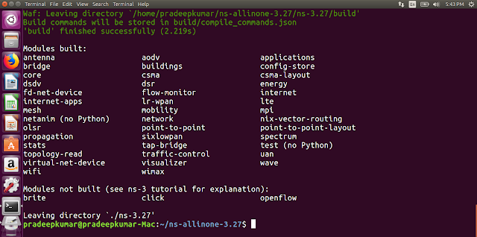](https://4.bp.blogspot.com/-bn2memgI8dI/WrZG1ZQ5ivI/AAAAAAABcrg/NHswT7qjtR8FVoNsv0meda1jaoh-oIGEgCLcBGAs/s1600/Screenshot+from+2018-03-24+17-43-46.png)

This indicates that ns3 is built successfully.

To check if any application is running. Do the following steps

$] cd ns-3.27/

$] ./waf --run hello-simulator

This will print the hello Simulator which indicates that ns3 is installed successfully.